Video presenter brief – RapidMooc

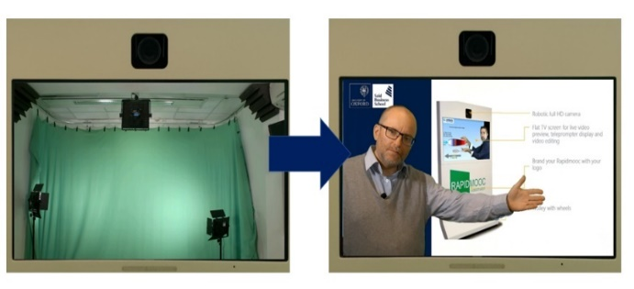
What is RapidMooc

RapidMooc is an all in one unit that records you with your presentation as background. You stand in front of a lit green screen and this will be replaced by whatever background you project from your laptop. You will see yourself on the screen to be able to adjust your position.
More information, documentation, and sample videos available on https://www.ctl.ox.ac.uk/rapidmooc.
Your presentation and your voice will be recorded and a video file is created that can be shared in any way videos are distributed (YouTube, Vimeo, Canvas).
RapicMooc is designed to make videos without the need for postproduction. You can edit the resulting video files but the idea is to create the final video before you leave the studio.
You can record as many times as you like, changing your presentation between takes to make it more suitable.
You can also prepare a script to read out using the built-in Autocue (Teleprompter).
The green-screen technology requires that you are brightly lit and the green screen is lit separately. Wearing contact lenses is preferable.

What to bring

Who can be in the room
RapidMooc is designed to be operated entirely independently to give the flexibility for iterative improvement. But some people like somebody there for feedback and to help control the recording equipment.

Slideshow / PowerPoint tips
Note: Ensure your PowerPoint is in Widescreen (16x9) – otherwise there will be black bars on the side of the video. You can format your slide show directly or use the template available via the RapidMooc site.
- Leave room for yourself (ideally about a 40% of the screen free)
- Do not have more than about 3 points per slide
- Try to avoid small text smaller than about 28pt
- Use photos across the whole slide (pixabay.com is a good source of nice images)
- Have an ending slide – this will tell you when to stop but will also make it easier for the audience to understand the end and even have some call to action – better than finishing on the last slide

What (NOT) to wear
The green-screen technology used by RapidMooc means that there are certain restrictions on what you can wear. Anything green will be translucent and anything very dark or fine checked will sparkle or create halos. Text will be recorded as mirror image. Your top should have some way of attaching the microphone. | 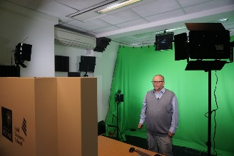
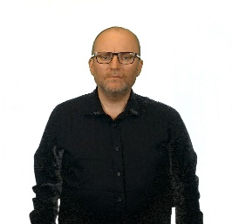

How should I present?
There are few simple things you can keep in mind that will improve your presentation:
- Speak as if you would to an audience, project you voice behind the screen and camera, not into it
- Get ready during initial countdown and look directly in the camera so that you are not moving when recording starts
- At the end of the recording pause and stay still for 5 seconds while you press stop
- Move left to right across the background but do not step back (camera will lose focus and you might be lit up by the lights that keep the green screen evenly lit
- Speak at a natural pace, do not try to speak too slowly
- Do not spend too much time on a single slide (no more than about 30 seconds) but do not advance slides with every sentence

Using a script

Speaking without a script (recommended)
- If speaking on a subject you know, it is better to speak without a script (most people find it difficult to read and sound natural)
- If you speak without a script, write down what you want to say at the start and end of the video (these are hard to improvise)

Preparing and using a script
- Script language: Break up the script into smaller sentences linked together with ‘but’, ‘or’, ‘and’ (E.g. ‘This was discovered which made people happy.’ is harder to read than ‘This was discovered. And this made people happy’). Prefer the use of verbs to nouns (e.g. ‘when you arrive’ is better than ‘upon arrival’). Avoid long noun clusters (e.g. replace ‘I am Joyce Smith, Head of Internal Innovation, Said Business School’ with ‘I’m Joyce Smith and I am the Head of Internal Innovation at the Said Business School.’
- Script formatting: The easiest way to create the script is to write it in the slide notes in the PowerPoint. You can also use a Word file but must save it as RTF (Rich Text Format. Bring the script on a USB Stick to load on the machine. Note: The script automatically advances as in an autocue – it does not behave like notes in PowerPoint presenter view.

Reading the script
If reading a script, make sure you insert plenty of pauses. Format the script to indicate when your pauses are.

