Three questions about representation to ask when researching inequality in education

Gaia Ardizzone
December 2023

The Creative Commons Licence, Attribution-Non-Commercial 4.0 International applies. We encourage you to use, adapt and build upon the material in any medium or format to suit your educational purposes (for non-commercial purposes only). We ask that you cite the resource and credit the Centre for Teaching and Learning as appropriate.
How to cite:
Ardizzone, Gaia. 2023. Three questions about representation to ask when researching inequality in education. The Diversity of Student Experience Project. The Centre for Teaching and Learning. University of Oxford.

About
I am the literature reporter on the Diversity of Student Experience Project, and a DPhil student in Medical Anthropology at the School of Anthropology and Museum Ethnography.
As part of the project, I have reported on what can be learned from interventions targeting vulnerable and at-risk groups. As the report drew to completion and we reflected on how to identify and target risk groups, several questions emerged about how to develop research that accurately reflects the issues faced by our research targets. Some of those questions are collected below, in the hope that those conducting fair, inclusive and accurate research will use this short piece as a reference.

Contents
About 3
Introduction 4
1. Question the golden standards of generalisability and statistical significance 5
2. Examine and challenge assumptions in research 5
3. Build inclusion into the research process 6
References cited 7

Introduction
Educational and social science research aim to understand the experiences, challenges and successes of students in order to identify strategies for improvement. However, the methodologies we use and the assumptions we hold shape the conclusions we draw. As researchers, we must thoughtfully consider issues of representation if we wish our findings to be meaningful and applicable, and if we wish to shape effective interventions.

Representation in education research refers to the intentional inclusion and equitable participation of individuals and groups from diverse backgrounds, identities, and experiences. It requires going beyond token participation by majority groups to actively facilitate voice and self-articulation of underrepresented people's perspectives, needs, challenges and priorities, including:
- Accurate understanding: research processes that systematically exclude certain people/groups will mischaracterize the barriers and needs such groups face. Accurate representation enables the accurate illumination of disparities.
- Challenging assumptions: unchallenged dominant paradigms embed assumptions into research that can misrepresent minority experiences if imposed uncritically. Facilitating self-representation allows marginalised voices to challenge power structures and residual biases embedded within mainstream research practices.
- Solution testing: policies and interventions aimed at addressing inequality cannot be effectively designed or evaluated without representation. Solutions often fail marginalised groups because they were never given a seat at the table to assess whether proposals meet their stated needs and interests.

Diversity and attentive representation in research are crucial for accuracy, ethical justice and solution effectiveness when confronting deeply entrenched education inequities that those most privileged have little knowledge of, or incentive to dismantle without inclusion of those who would benefit from change. Researchers need to be aware of their own assumptions and bias when formulating research questions, and need to pay careful attention to who they identify as responders and targets, as these considerations in turn inform methodological approaches and intervention strategies, and ultimately shape conclusions and future research.

So how can we make sure that, as researchers, we ask appropriate questions and get answers from those whose voices have historically and systematically been marginalised?

Question the golden standards of generalisability and statistical significance
What you should ask: Is generalisability a necessary aspect of this study? What can be gained or lost from it?

Why you should ask: Many researchers value large, statistically representative studies that allow conclusions to be generalised to wider populations. However, solely pursuing this type of research has limitations. Smaller qualitative studies often provide crucial insights into the needs of minority and marginalised groups that quantitative data can overlook. While a representative study might tell us that a percentage of students struggle with a particular issue, a qualitative study might illuminate why certain students struggle and how their experiences with the same issue differ. Both statistical significance and in-depth understanding of subgroups are important.

Researchers must thoughtfully weigh generalisability against inclusivity when designing their studies. While representative sampling seems intuitively desirable, minority groups are often excluded simply due to their small numbers. Yet understanding their distinct needs is vital for developing supportive interventions. Representativeness should not be pursued at the expense of hearing from vulnerable voices. Multi-method approaches that incorporate both qualitative investigations of underrepresented groups alongside wider surveys can provide a more complete picture.

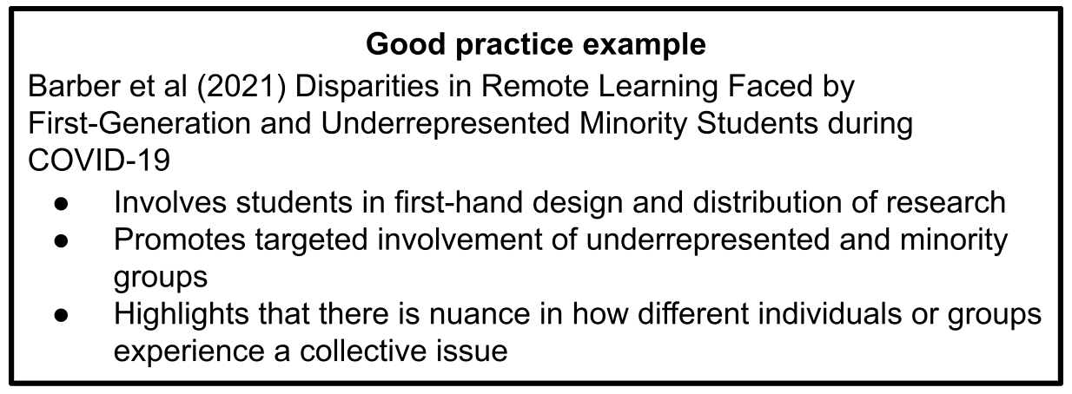

Examine and challenge assumptions in research
What you should ask: Do pre-determined categories of representation reflect the ways subjects of research identify? Who is excluded and/or included in this research and why?

Why you should ask: Social science research has often uncritically replicated dominant assumptions about categories like race, class, gender, and disability. For example, researchers regularly aggregate diverse ethnic groups into simplistic categories like “Black” or “Asian” without considering how this obscures substantive personal, cultural, and/or geographical differences in experience. Or they may assemble disability data without examining potential differences between physical disabilities, learning disabilities, chronic illnesses and mental health conditions.

Such broad brushstroke categories often stem from the assumptions and perspectives of the majority group. They can exclude minority groups entirely if they are considered too small to analyse separately. Researchers have an ethical duty to question whether these categories accurately or adequately reflect the self-conceptions and the complex nodes of experience of minority group members.

Methodologies should leave space for minority groups to articulate their own identities, as well as their challenges and needs, in their own words. Qualitative approaches that include interviews, focus groups, participatory research and narrative analysis can enable this. Researchers should also continually reflect upon their own assumptions, cultural biases and positions of relative privilege when interpreting minority experiences. A decolonizing research ethic requires an openness to having our preconceptions challenged and to incorporate new-found understandings of human experience into research.

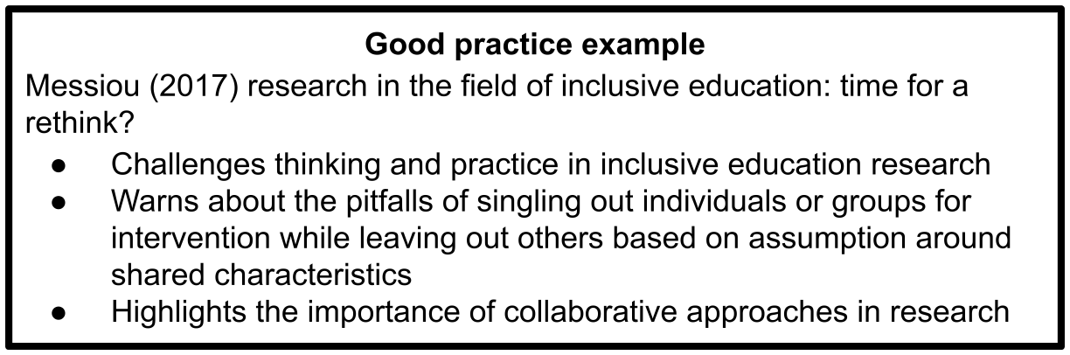

Build inclusion into the research process
What you should ask: How can adequate representation be built into research? What methodologies and approaches are most suited?

Why you should ask it: Inclusive methodologies are essential for ethical, accurate and effective research aiming to understand and address educational inequality. Without thoughtful consideration of representation, studies risk perpetuating the marginalisation of minority voices, along with the misrepresentation of research/intervention targets, failing to meet the needs of multiple student groups.

Researchers have an obligation to continually reflect on issues of power, privilege and voice. We must question the validity of dominant paradigms, be open to having assumptions challenged, and create opportunities for marginalised communities to shape inquiry based on self-articulated experiences.

Asking how to facilitate participation, narrative expression and co-direction of lines of inquiry by groups made invisible by mainstream practices is vital. Which research designs, sampling approaches, analyses and applications of findings can uphold equitable representation? Some tips include: considering methodological pluralism, blending qualitative and quantitative methods and leveraging the strengths of each; ensuring representative diversity in qualitative samples; facilitating participant-led inquiry; allowing flexibility around identity categories, being open to critiquing existing identity categories and allowing participants space for their perspectives and experiences.

Adopting inclusive methodologies requires more time, care and reflexivity from researchers. But enhancing representation in research is an ethical obligation; minority groups should not need to compromise their cultural identities and self-understandings to participate in studies aiming to help them succeed. Careful attention to diversity that is translated into rigorous and inclusive methodologies will produce better insights and interventions for all students.

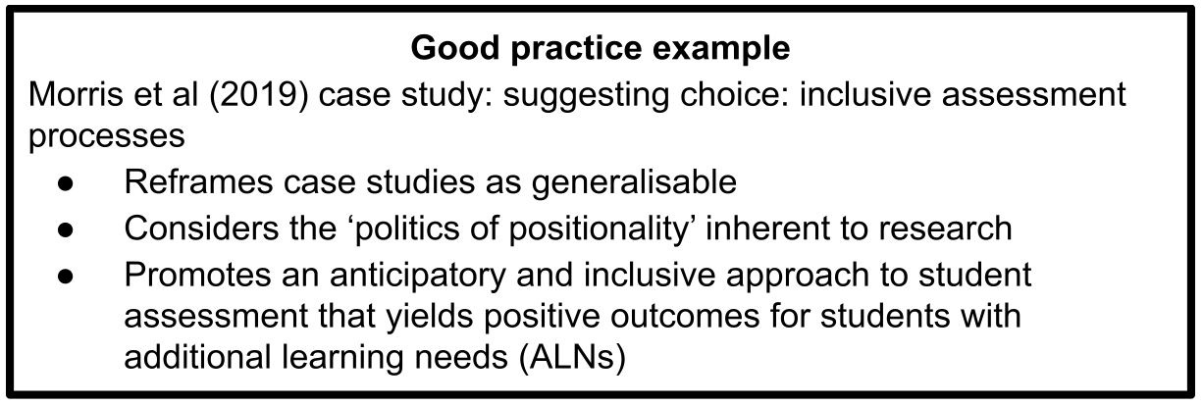

References cited
P. H. Barder, C. Shapiro, M. S. Jacobs, L. Avilez, K. I. Brenner, C. Cabral, M. Cebreros, E. Cosentino, C. Cross, M. L. Gonzalez, K. T. Lumada, A. T. Menjivar, J. Narvaez, B. Olmeda, R. Phelan, D. Purdy, S. Salam, L. Serrano, M. J. Velasco, E. Zerecero Marin & M. Levis-Fitzgerald (2021) Disparities in remote learning faced by first-generation and underrepresented minority students during COVID-19: Insights and opportunities from a remote research experience. Journal of Microbiology & Biology Education, 22(1). DOI: 10.1128/jmbe.v22i1.2457
K. Messiou (2017) Research in the field of inclusive education: time for a rethink?*. International Journal of Inclusive Education, 21(2): 146-159. DOI: 10.1080/13603116.2016.1223184

C. Morris, E. Milton & R. Goldstone (2019) Case study: suggesting choice: inclusive assessment processes. Higher Education Pedagogies, 4(1): 435-447. DOI: 10.1080/23752696.2019.1669479

